

**VISHWAKARMA COLLEGE OF ARTS**

**COMMERCE AND SCIENCE**

**PUNE – 411048**

**NAAC ACCREDITED WITH ‘A’ GRADE**

**AY 2024-2025**

**A PROJECT ON**

**Blood Bank Management System**

**Submitted to**

Savitribai Phule Pune University

In partial fulfilment of the requirements

for the degree of

**Bachelor of Science (Computer Science)**

**BY**

**Sharma Gautam Mahaveer Prasad**

**Under the guidance of**

Asst. Prof. Atharv Ekbote



**VISHWAKARMA COLLEGE OF ARTS**

**COMMERCE AND SCIENCE**

**PUNE – 411048**

**NAAC ACCREDITED WITH ‘A’ GRADE**

**AY 2024-2025**

**CERTIFICATE**

This is to certify that,

**Sharma Gautam Mahaveer Prasad**

Your Seat Number of Vishwakarma College Of Arts Commerce And Science Pune,

Of **Bachelor of Science (Computer Science)** class has completed

project report on **Blood Bank Management System**

As prescribed by the Savitribai Phule Pune University, in the acadmic year

2024-2025.

Project Guide        Head of Department                             Principal

(Asst. Prof. Atharv Ekbote)         (Dr Sudhir Chitnis)                           (Dr Arun Patil)

Internal Examiner                                                                            External Examiner

Date:

Remark:

**Index**

| **Sr. No.** | **Section & Subsections** |
| --- | --- |
| 1 | **Abstract** |
| 2 | **Introduction** |
|  | 2.1 Problem Statement |
|  | 2.2 Purpose/Objectives & Goals |
|  | 2.3 Project Scope & Limitations |
|  | 2.4 Software and Hardware Specifications |
| 3 | **System Analysis** |
|  | 3.1 Existing System |
|  | 3.2 Scope and Limitations of Existing System |
|  | 3.3 Project Perspective & Features |
|  | 3.4 Stakeholders |
|  | 3.5 Requirement Analysis |
| 4 | **System Diagrams** |
|  | 4.1 ER Diagram |
|  | 4.2 Class Diagram |
|  | 4.3 Use Case Diagram |
|  | 4.4 Sequence Diagram |
|  | 4.5 Activity Diagram |
| 5 | **Data Dictionary** |
|  | Hospital Table |
|  | user Table |
|  | donor Table |
|  | blood_inventory Table |
|  | donations Table |
|  | Inventory_logs Table |
| 6 | **Input Screens** |
| 7 | **Test Cases** |
| 8 | **Conclusion and Recommendations** |
| 9 | **Future Scope** |
| 10 | **Bibliography and References** |

1. **Abstract – Blood Bank Management System**

The Blood Bank Management System (BBMS) is a web-based platform designed to streamline and enhance the process of blood donation, storage, and distribution. It serves as a vital bridge between donors, recipients, and healthcare institutions, ensuring efficient blood availability and management.

This system facilitates real-time donor registration, blood inventory tracking, hospital and recipient requests, and automated alerts for critical shortages. With a user-friendly interface, it enables donors to find nearby blood banks, schedule donations, and track their donation history. Hospitals and clinics can request specific blood types, check availability, and manage emergency requirements seamlessly.

Security and data accuracy are key priorities, with features like role-based access control, secure authentication, and data encryption to protect sensitive donor and recipient information. The system also integrates with healthcare databases for better coordination and transparency.

By digitalizing the blood donation process, the Blood Bank Management System aims to reduce shortages, minimize wastage, and ensure timely blood transfusions, ultimately saving lives and improving healthcare efficiency.

2. Introduction

**2.1. Problem Statement:**

Blood donation and transfusion are critical components of healthcare, yet many hospitals and blood banks face challenges such as lack of real-time blood availability, improper donor records, and inefficient inventory management. Manual processes lead to delays, mismanagement, and even wastage of blood, which can be life-threatening in emergencies. There is a need for a centralized, automated system that ensures efficient donor registration, real-time inventory tracking, and quick blood requests and donations to meet urgent medical needs.

**2.2. Purpose / Objective:**

The purpose of the Blood Bank Management System (BBMS) is to create a digital platform that streamlines the process of blood donation, storage, and distribution. The system aims to:

- Automate the registration and management of blood donors and recipients.

- Provide real-time inventory tracking of available blood units.

- Enable hospitals and blood banks to request and access blood efficiently.

- Reduce wastage of blood by optimizing storage and usage.

- Enhance communication between donors, hospitals, and blood banks through alerts and notifications.

**2.3. Goals:**

- Ensure quick and efficient blood donation and transfusion processes.

- Maintain accurate donor and recipient records with their medical history.

- Enable real-time blood stock updates and inventory management.

- Implement automated notifications to donors and hospitals in case of shortages.

- Integrate security measures to protect sensitive donor and recipient data.

- Provide easy accessibility through a user-friendly web and mobile interface.

**2.4. Project Scope and Limitations:**

**Scope :**

- The system will support donor registration, hospital requests, and inventory tracking.

- Users (donors, hospitals, blood banks) will have role-based access to the system.

- Notifications and alerts will be implemented to notify donors about upcoming donation opportunities.

- The system will generate reports on blood stock levels, donor history, and transfusion records.

- Search functionality to find nearby blood banks and available blood types.

**Limitations :**

- The system does not perform medical screening of donors; it only maintains their records.

- It requires internet connectivity to function effectively.

- Blood transportation and handling must be managed manually outside the system.

- Limited to hospitals, blood banks, and donors registered in the system.

**2.5. Software and Hardware Specifications:**

* **Software Requirements:**

- **Operating System** : Windows / Linux / macOS

- **Database :** MySQL / PostgreSQL

- **Programming Languages :** PHP, Python, Java, or Node.js

- **Frontend Technologies :** HTML, CSS, JavaScript, React/Angular

- **Backend Framework :** Laravel / Django / Express.js

- **Server :** Apache / Nginx

- Mobile App (Optional): Flutter / React Native for Android & iOS

* **Hardware Requirements:**

- **Processor :** Intel i5 or higher / AMD Ryzen 5 or higher

- **RAM :** Minimum 8GB (Recommended: 16GB for optimal performance)

- **Storage :** Minimum 100GB HDD or SSD

- **Server Requirements :** Cloud-based hosting (AWS, Google Cloud, or Azure) or an on-premises server

- **Internet Connection :** High-speed connection for seamless communication between users

**3.1. Existing Systems:**

Currently, most blood banks and hospitals use manual or semi-automated systems for blood donation and inventory management. Some organizations have basic digital systems, but they lack real-time updates, accessibility, and efficiency. The existing systems face challenges such as:

- **Manual record-keeping**, which increases the risk of errors.

- **Lack of real-time updates**, leading to delayed responses in emergencies.

- **Limited donor outreach**, as donors are not actively notified when their blood type is needed.

- **Difficulty in tracking donations**, expiration dates, and availability of blood types.

**3.2. Scope and Limitations of Existing Systems:**

**Scope :**

- Basic donor and recipient records are maintained.

- Some hospitals have **inventory tracking**, but it is not always updated in real-time.

- Blood banks can record donations manually and match them with patient requests.

**Limitations :**

- **No centralized database**, leading to a lack of coordination between hospitals and blood banks.

- **No automated alerts or notifications** for donors and hospitals in case of shortages.

- **Limited accessibility** since many systems are not available online or on mobile platforms.

- **Data security risks** due to lack of encryption and security measures in existing systems.

**3.3. Project Perspective & Features:**

**Project Perspective :**

The Blood Bank Management System (BBMS) aims to provide a centralized, automated platform to bridge the gap between donors, blood banks, and hospitals. It ensures real-time tracking, secure record-keeping, and efficient communication for blood donation and distribution.

**Key Features** :

✅ **Donor Registration & Management** – Register donors, track donation history, and verify eligibility.

✅ **Real-Time Blood Inventory** – Display available blood types and their quantities in real time.

✅ **Blood Request & Allocation** – Allow hospitals and patients to request blood easily.

✅ **Automated Notifications** – Send alerts to donors about donation camps and urgent blood requirements.

✅ **Search Nearby Blood Banks** – Enable users to locate blood banks with specific blood types.

✅ **Secure Data Management** – Implement encryption and role-based access to protect sensitive information. ✅ **Reports & Analytics** – Generate insights on blood availability, donor trends, and hospital demands.

**3.4. Stakeholders:**

The system will involve multiple stakeholders, including :

👨‍⚕️ **Hospitals & Healthcare Providers** – Request and track blood availability.

🏥 **Blood Banks** – Manage inventory, donor records, and transfusion records.

💉 **Blood Donors** – Register, track donations, and receive alerts when their blood type is needed.

🧑‍🤝‍🧑 **Patients & Recipients** – Request and receive blood from hospitals.

👨‍💻 **System Administrators** – Maintain the platform, manage user roles, and ensure data security.

**3.5. Requirement Analysis:**

**A. Functional Requirements :**

- Donor registration and blood donation tracking.

- Blood request and approval system.

- Real-time blood inventory updates.

- Automated notifications for donors and hospitals.

- Secure login and role-based access for users.

- Search functionality for finding nearby blood banks.

**B. Performance Requirements :**

- The system should handle high traffic and multiple requests simultaneously.

- Response time should be minimal to ensure quick updates and requests.

- The database should support large-scale donor and blood inventory records without delays.

**C. Security Requirements :**

- User authentication & role-based access to prevent unauthorized modifications.

- Data encryption to protect donor and patient information.

- Regular data backups to prevent data loss.

- Audit logs to track all changes in the system for accountability.

**4. SYSTEM DESIGN**

1. ER Diagram

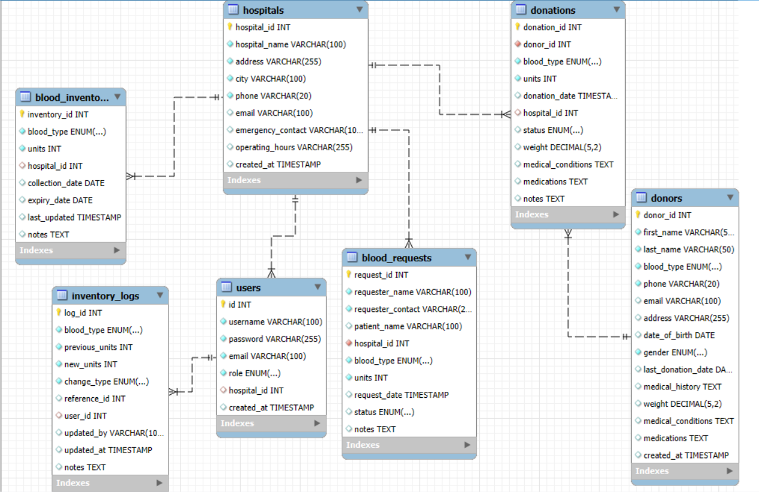

2. Class Diagram

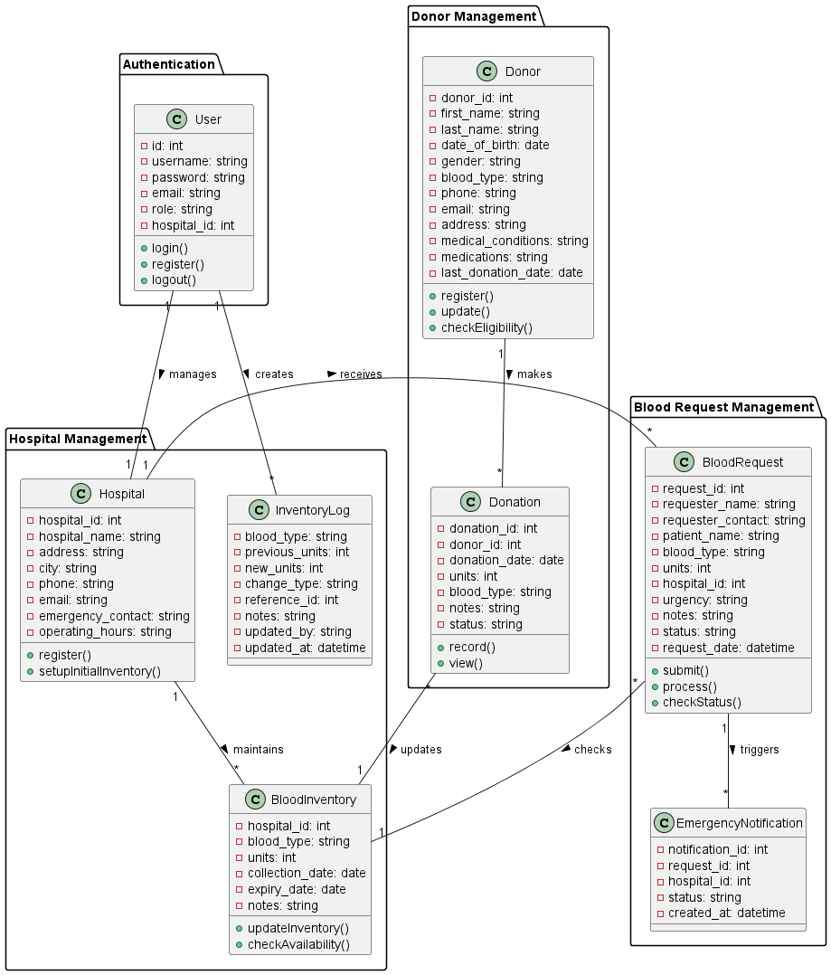

**3. Use Case Diagram**

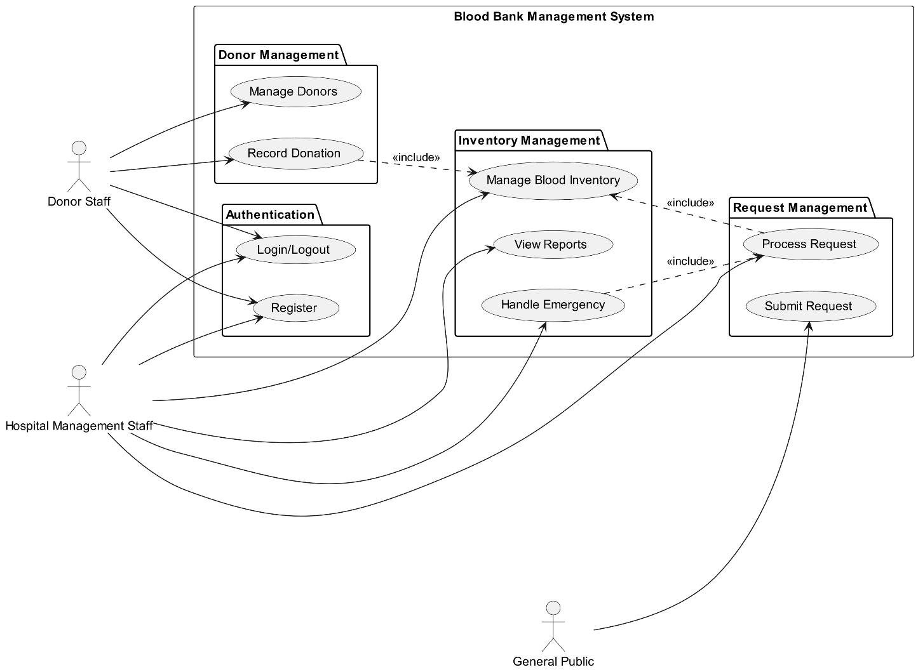

**4. Sequence Diagram**

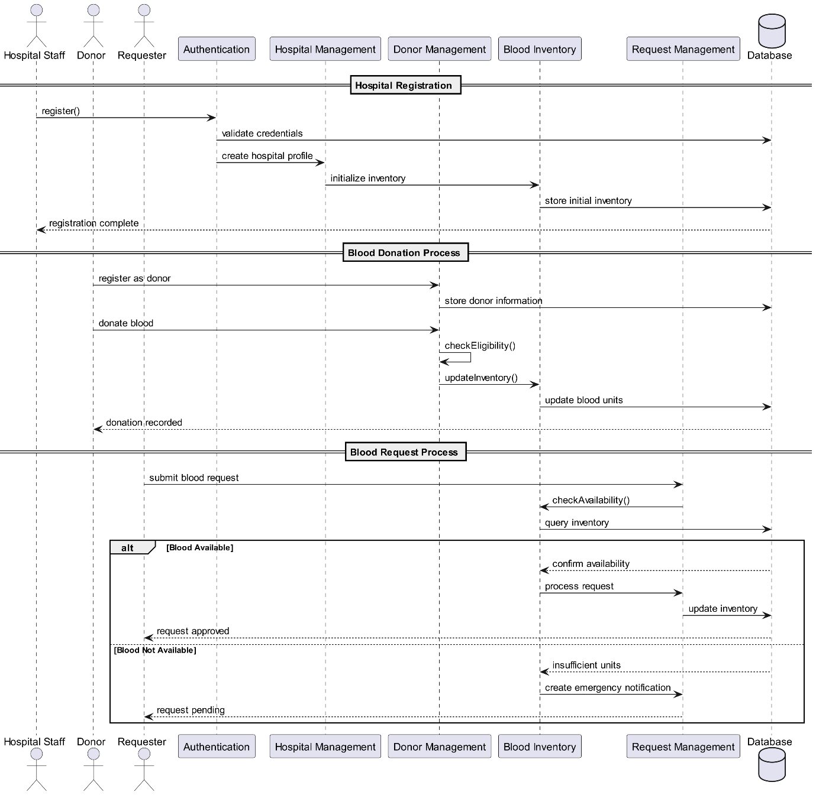

**5. Activity Diagram**

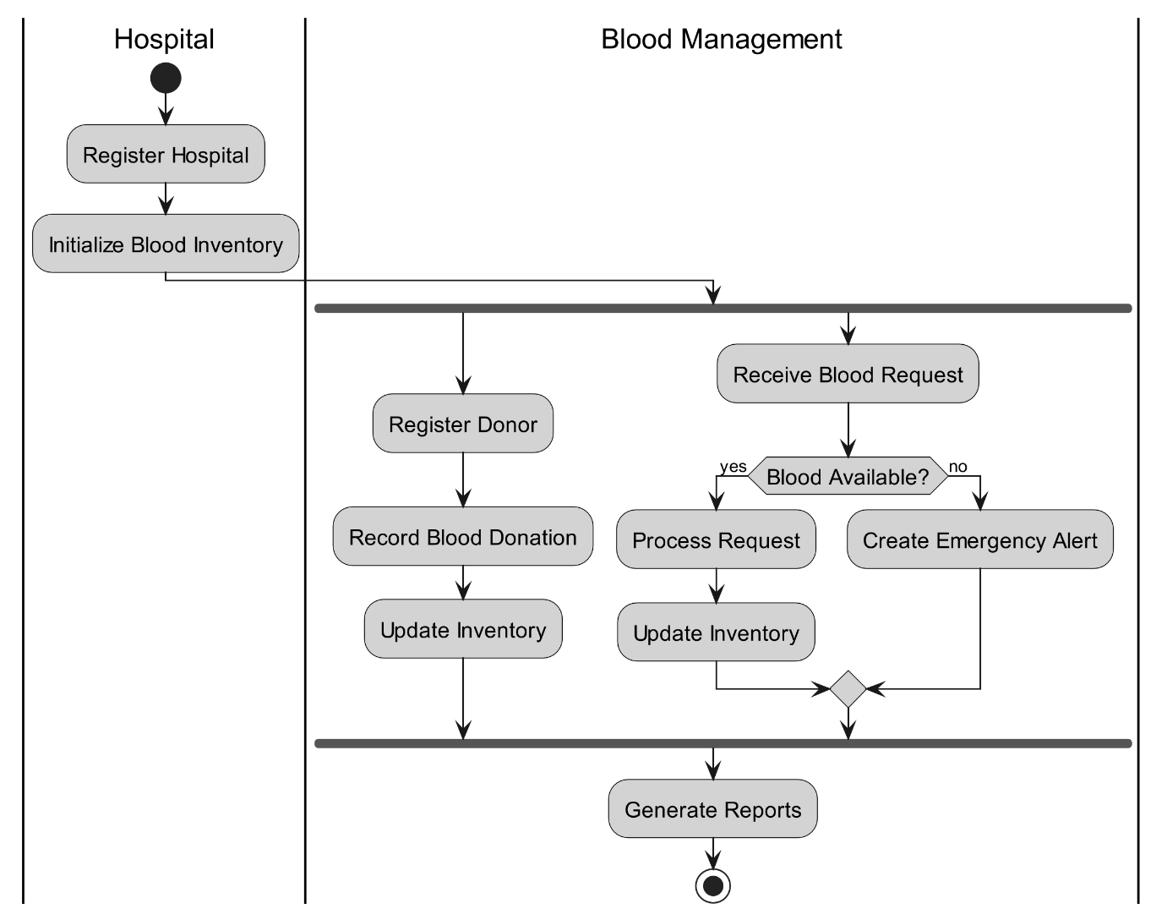

**5. Data Dictionary**

1. hospitals Table (Stores Hospital’s Details)

|  |  |  |
| --- | --- | --- |
| Column Name | Data Type | Constraints |
| hospital_id | INT | AUTO_INCREMENT PRIMARY KEY |
| hospital_name | VARCHAR(100) | NOT NULL |
| address | VARCHAR(255) | NOT NULL |
| city | VARCHAR(100) | NOT NULL |
| phone | VARCHAR(20) | NOT NULL |
| email | VARCHAR(100) | None |
| emergency_contact | VARCHAR(100) | None |
| operating_hours | VARCHAR(255) | None |
| created_at | TIMESTAMP | DEFAULT CURRENT_TIMESTAMP |

2. users Table

|  |  |  |
| --- | --- | --- |
| Column Name | Data Type | Constraints |
| id | INT | AUTO_INCREMENT PRIMARY KEY |
| username | VARCHAR(100) | NOT NULL UNIQUE |
| password | VARCHAR(255) | NOT NULL |
| email | VARCHAR(100) | NOT NULL UNIQUE |
| role | ENUM | ('donor_staff','management_staff') NOT NULL |
| hospital_id | INT | None |
| created_at | TIMESTAMP | DEFAULT CURRENT_TIMESTAMP |
| FOREIGN | KEY | (hospital_id) REFERENCES hospitals(hospital_id) |

3. donors

|  |  |  |
| --- | --- | --- |
| **Column Name** | **Data Type** | **Constraints** |
| donor_id | INT | AUTO_INCREMENT PRIMARY KEY |
| first_name | VARCHAR(50) | NOT NULL |
| last_name | VARCHAR(50) | NOT NULL |
| blood_type | ENUM | ('A+','A-', 'B+', 'B-', 'AB+', 'AB-', 'O+', 'O-') NOT NULL |
| phone | VARCHAR(20) | NOT NULL |
| email | VARCHAR(100) | None |
| address | VARCHAR(255) | None |
| date_of_birth | DATE | None |
| gender | ENUM | ('M','F', 'Other') NOT NULL |
| last_donation_date | DATE | None |
| medical_history | TEXT | None |
| weight | DECIMAL(5,2) | None |
| medical_conditions | TEXT | None |
| medications | TEXT | None |
| created_at | TIMESTAMP | DEFAULT CURRENT_TIMESTAMP |

4. blood_inventory

|  |  |  |
| --- | --- | --- |
| **Column Name** | **Data Type** | **Constraints** |
| inventory_id | INT | AUTO_INCREMENT PRIMARY KEY |
| blood_type | ENUM | ('A+','A-', 'B+', 'B-', 'AB+', 'AB-', 'O+', 'O-') NOT NULL |
| units | INT | NOT NULL DEFAULT 0 |
| hospital_id | INT | None |
| collection_date | DATE | None |
| expiry_date | DATE | None |
| last_updated | TIMESTAMP | DEFAULT CURRENT_TIMESTAMP |
| notes | TEXT | None |
| FOREIGN | KEY | (hospital_id) REFERENCES hospitals(hospital_id) |
| UNIQUE | KEY | (blood_type, hospital_id) |
| request_id | INT | AUTO_INCREMENT PRIMARY KEY |
| requester_name | VARCHAR(100) | NOT NULL |
| requester_contact | VARCHAR(20) | NOT NULL |
| patient_name | VARCHAR(100) | None |
| hospital_id | INT | NOT NULL |
| blood_type | ENUM | ('A+','A-', 'B+', 'B-', 'AB+', 'AB-', 'O+', 'O-') NOT NULL |
| units | INT | NOT NULL |
| request_date | TIMESTAMP | DEFAULT CURRENT_TIMESTAMP |
| status | ENUM | ('pending','approved', 'rejected', 'fulfilled') DEFAULT 'pending' |
| notes | TEXT | None |
| FOREIGN | KEY | (hospital_id) REFERENCES hospitals(hospital_id) |

5. donations

|  |  |  |
| --- | --- | --- |
| **Column Name** | **Data Type** | **Constraints** |
| donation_id | INT | AUTO_INCREMENT PRIMARY KEY |
| donor_id | INT | NOT NULL |
| blood_type | ENUM | ('A+','A-', 'B+', 'B-', 'AB+', 'AB-', 'O+', 'O-') NOT NULL |
| units | INT | NOT NULL DEFAULT 1 |
| donation_date | TIMESTAMP | DEFAULT CURRENT_TIMESTAMP |
| hospital_id | INT | None |
| status | ENUM | ('pending','approved', 'rejected') DEFAULT 'pending' |
| weight | DECIMAL(5,2) | None |
| medical_conditions | TEXT | None |
| medications | TEXT | None |
| notes | TEXT | None |
| FOREIGN | KEY | (donor_id) REFERENCES donors(donor_id) |
| FOREIGN | KEY | (hospital_id) REFERENCES hospitals(hospital_id) |

6. inventory_logs

|  |  |  |
| --- | --- | --- |
| **Column Name** | **Data Type** | **Constraints** |
| log_id | INT | AUTO_INCREMENT PRIMARY KEY |
| blood_type | ENUM | ('A+','A-', 'B+', 'B-', 'AB+', 'AB-', 'O+', 'O-') NOT NULL |
| previous_units | INT | NOT NULL |
| new_units | INT | NOT NULL |
| change_type | ENUM | ('donation','request', 'expiry', 'adjustment', 'manual') NOT NULL |
| reference_id | INT | None |
| user_id | INT | None |
| updated_by | VARCHAR(100) | None |
| updated_at | TIMESTAMP | DEFAULT CURRENT_TIMESTAMP |
| notes | TEXT | None |
| FOREIGN | KEY | (user_id) REFERENCES users(id) |

**6. Input Screens**

* Homepage :

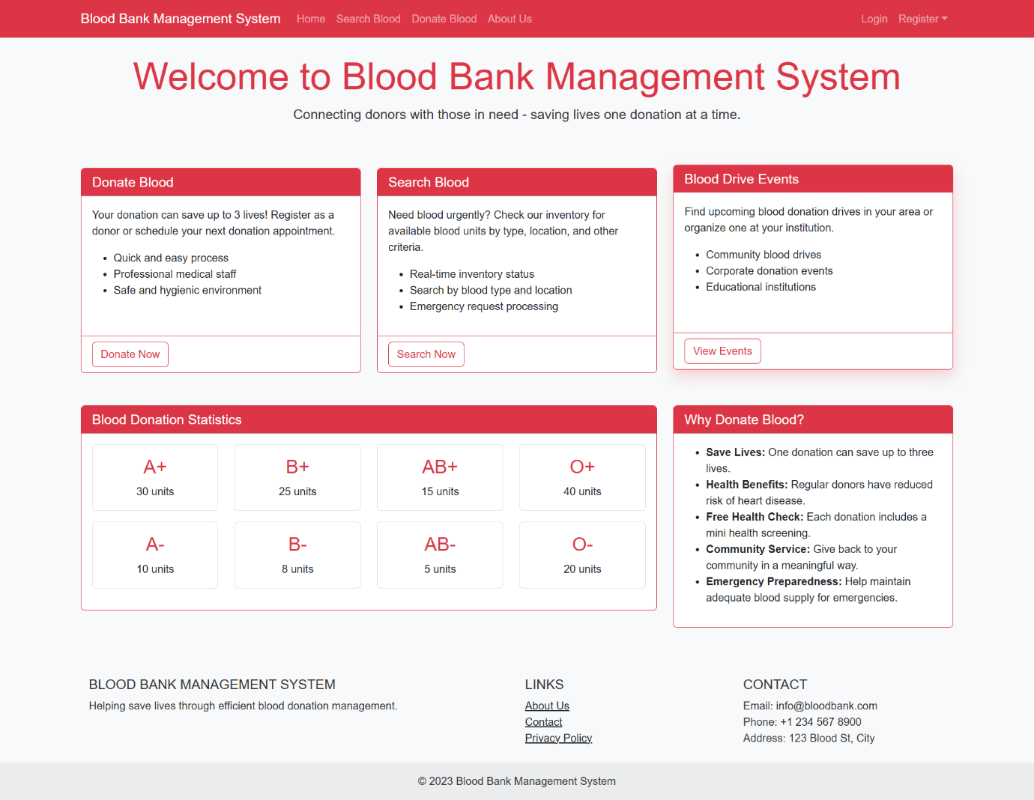

* Search Blood Availability :

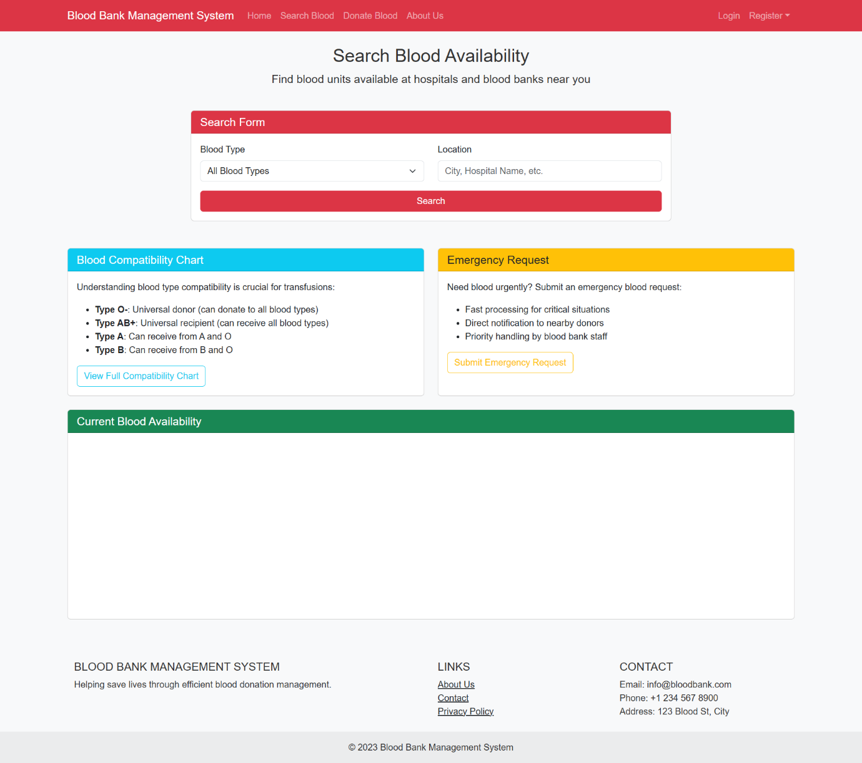

* Search Results

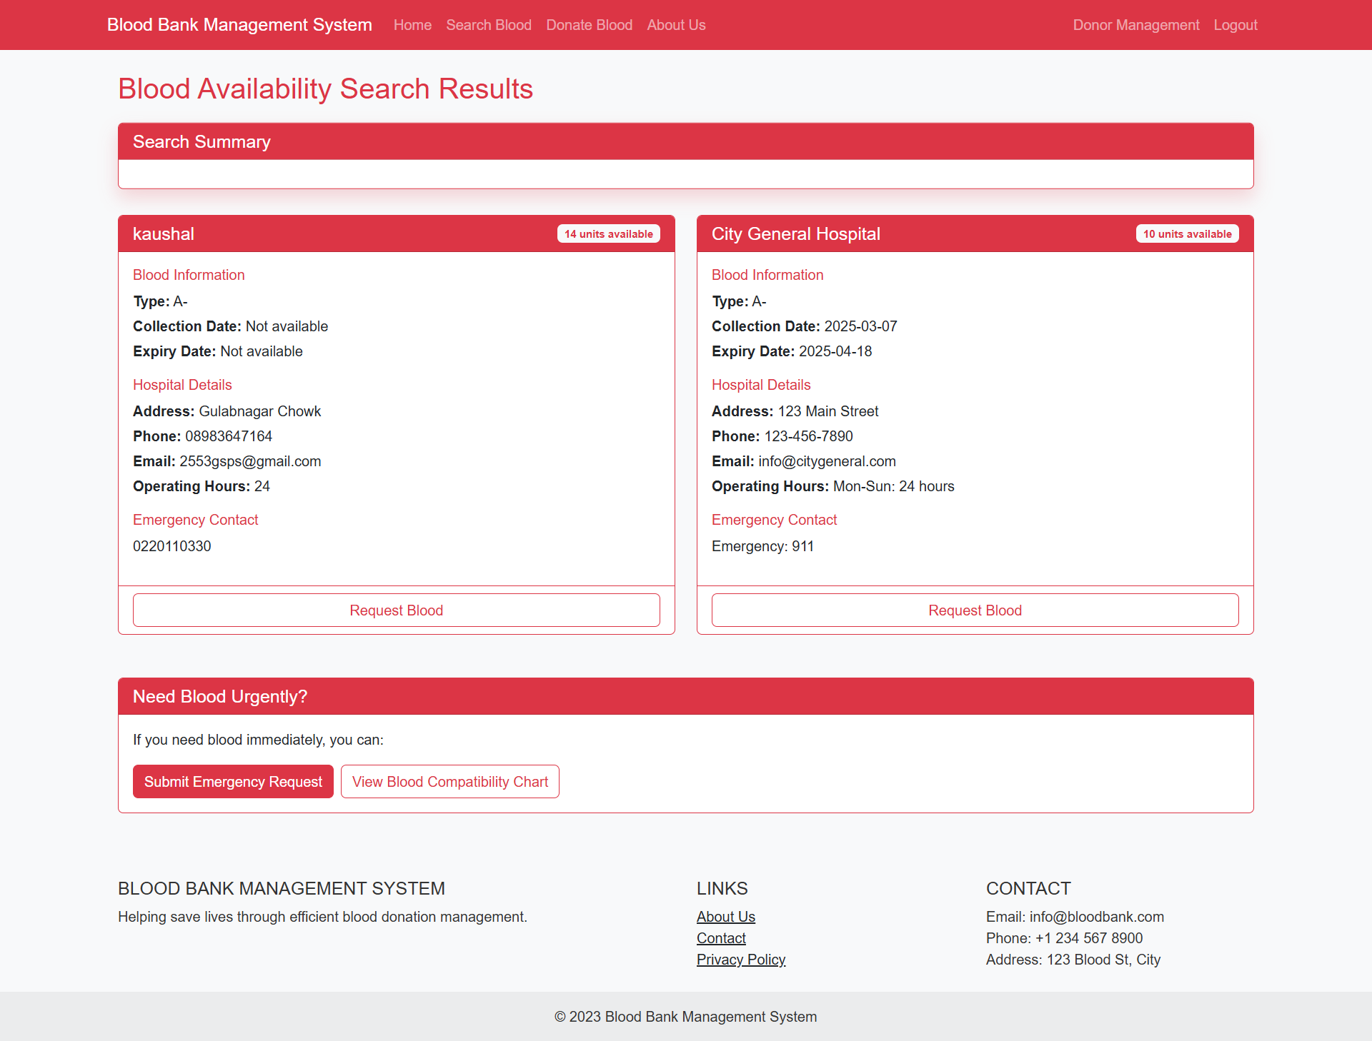

* Emergency Request Page

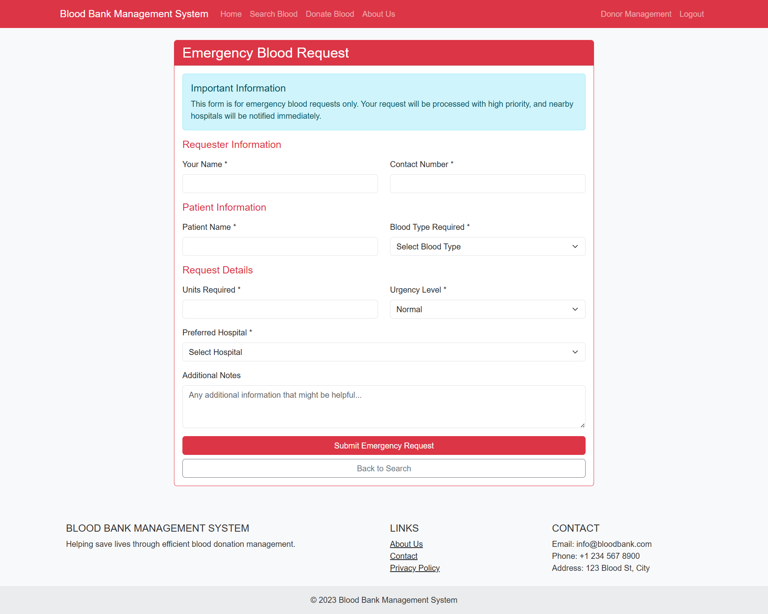

* Registration Page :

i) Staff Registration Page -

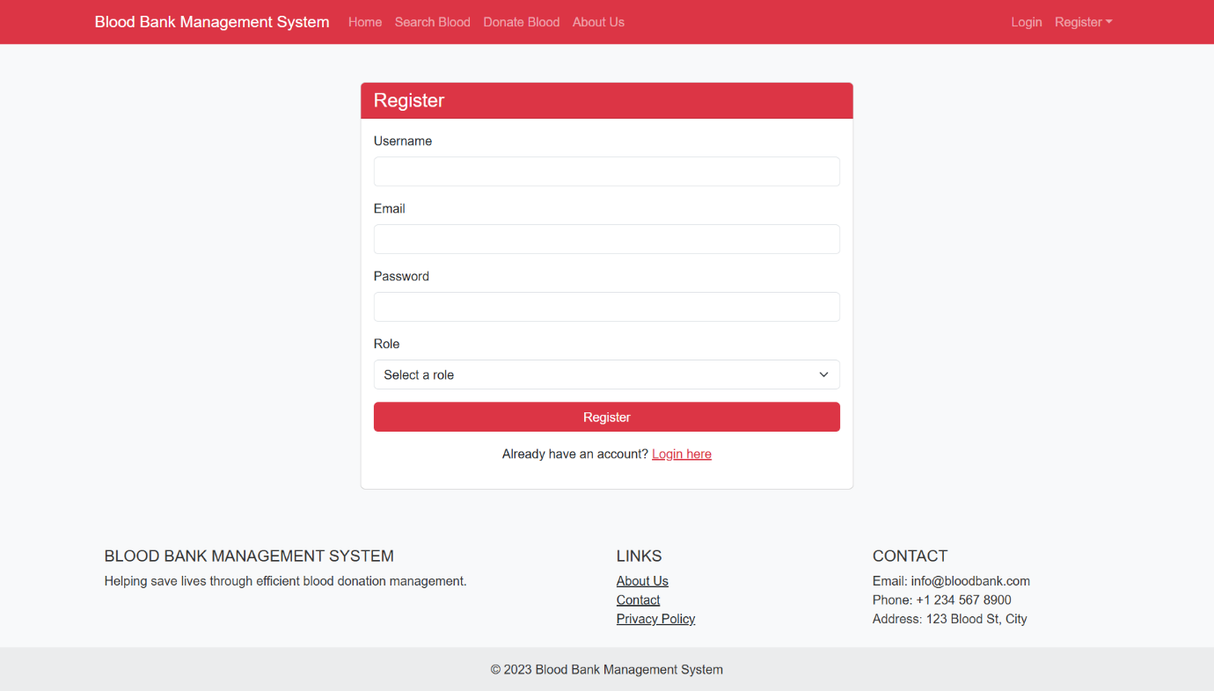

ii) Hospital Registration Page –

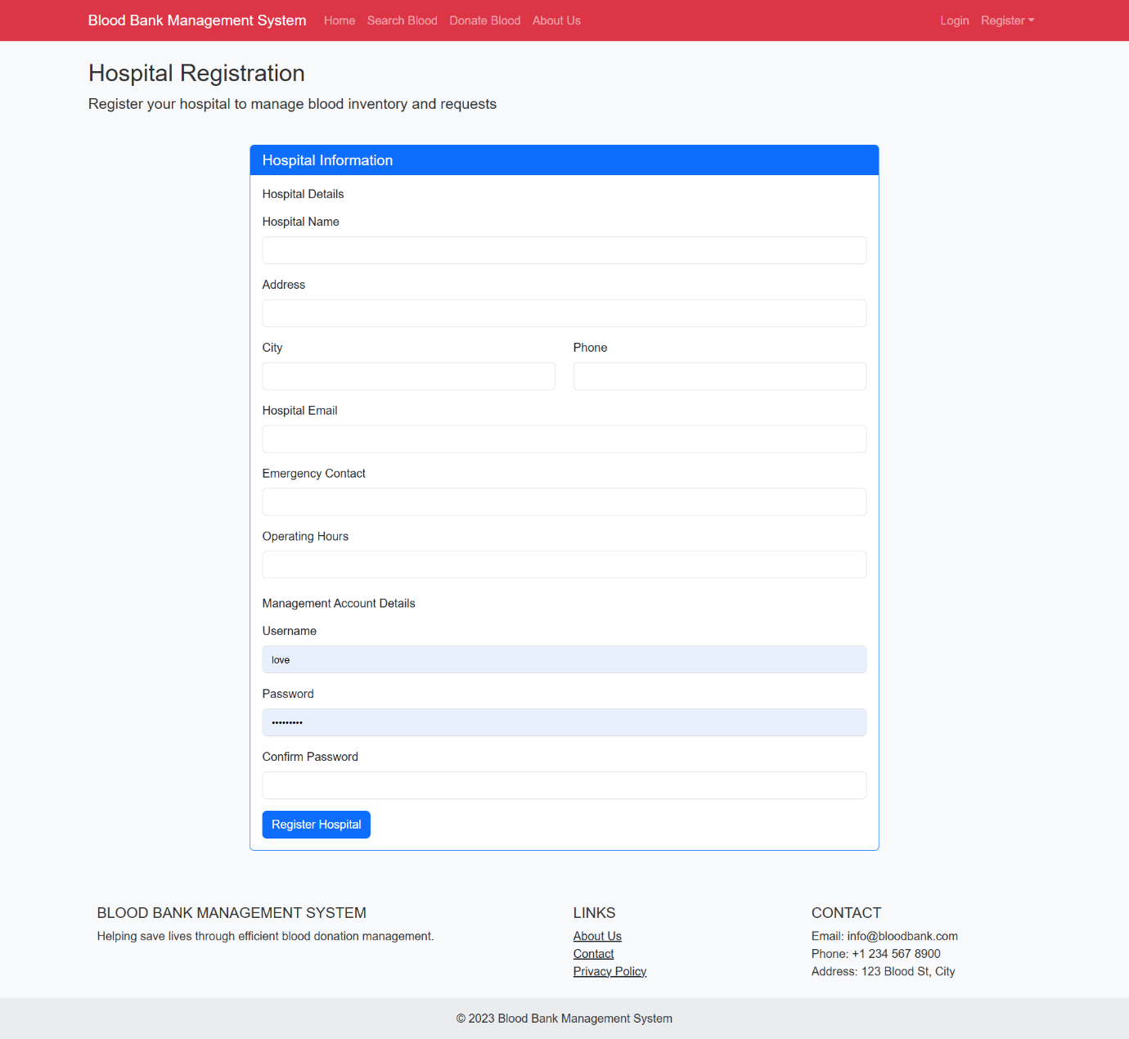

* Initial (Hospital’s) Inventory Setup Page :

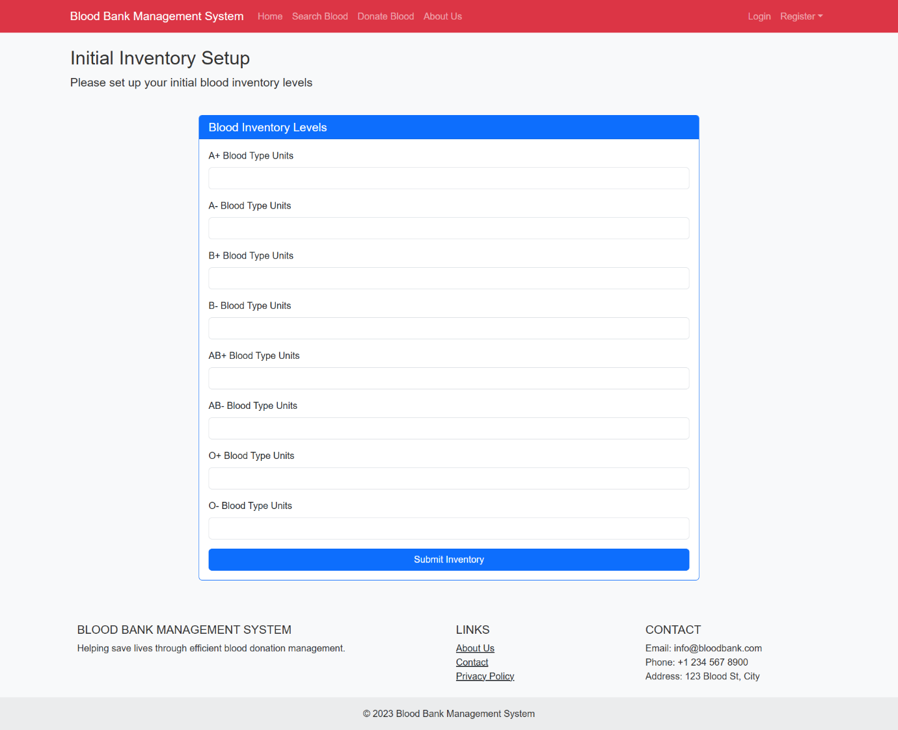

* Hospital’s Login Page :

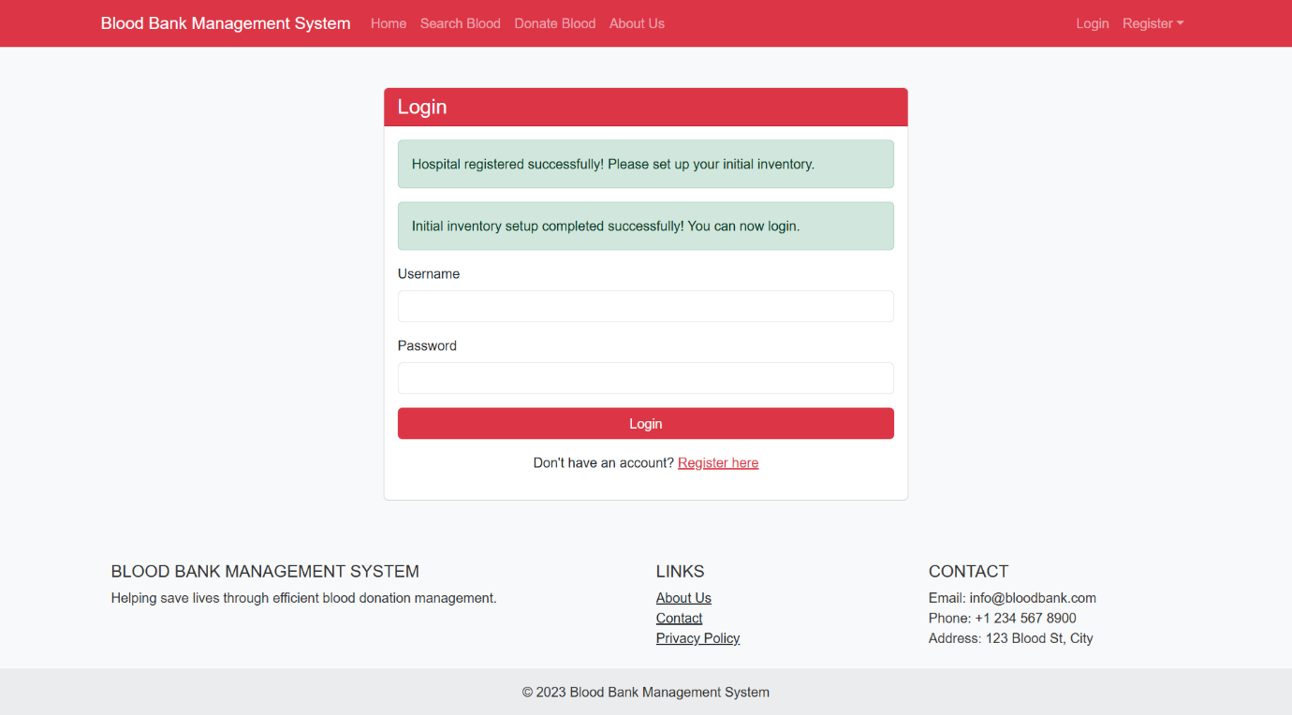

* Hospital’s Dashboard

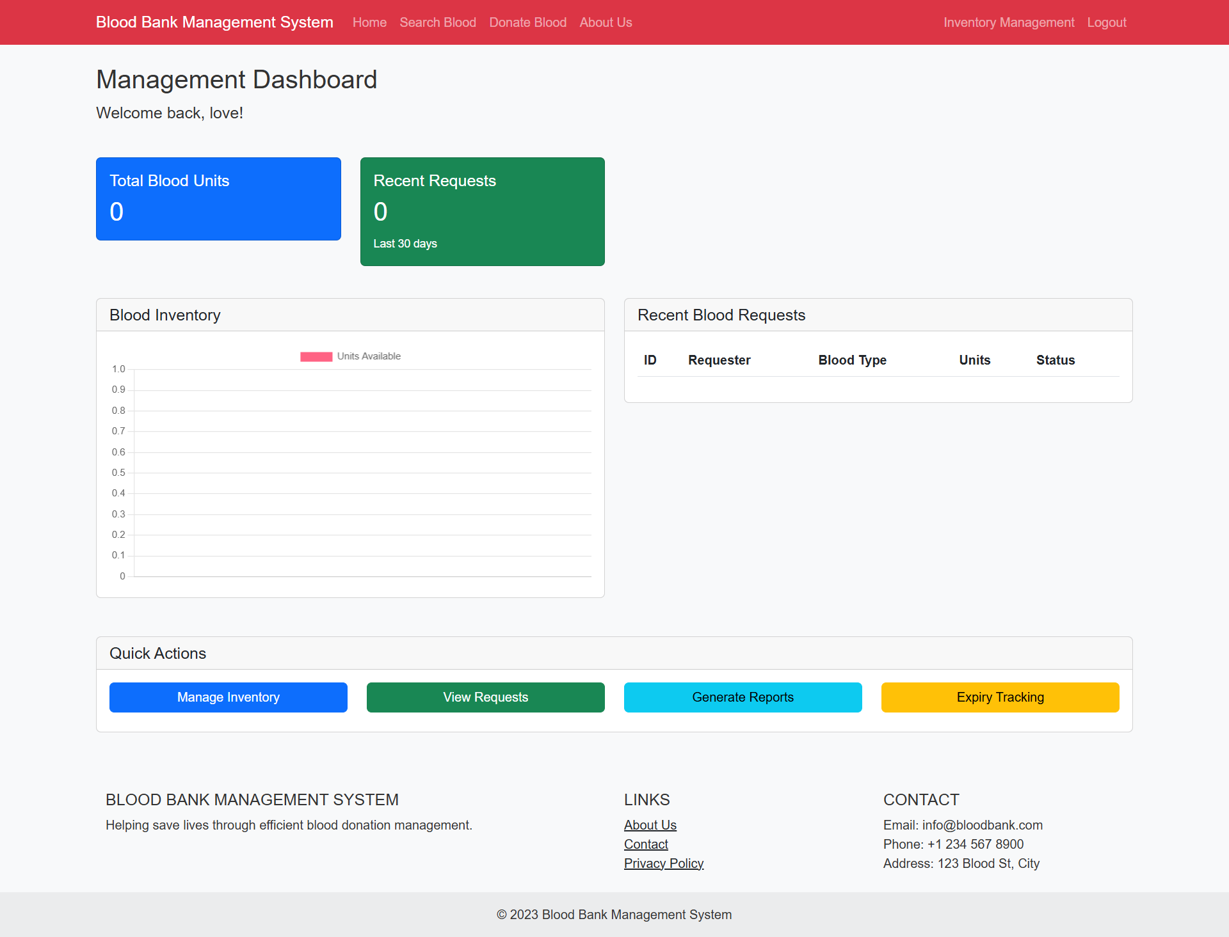

* Hospital’s Blood Inventory Management Page

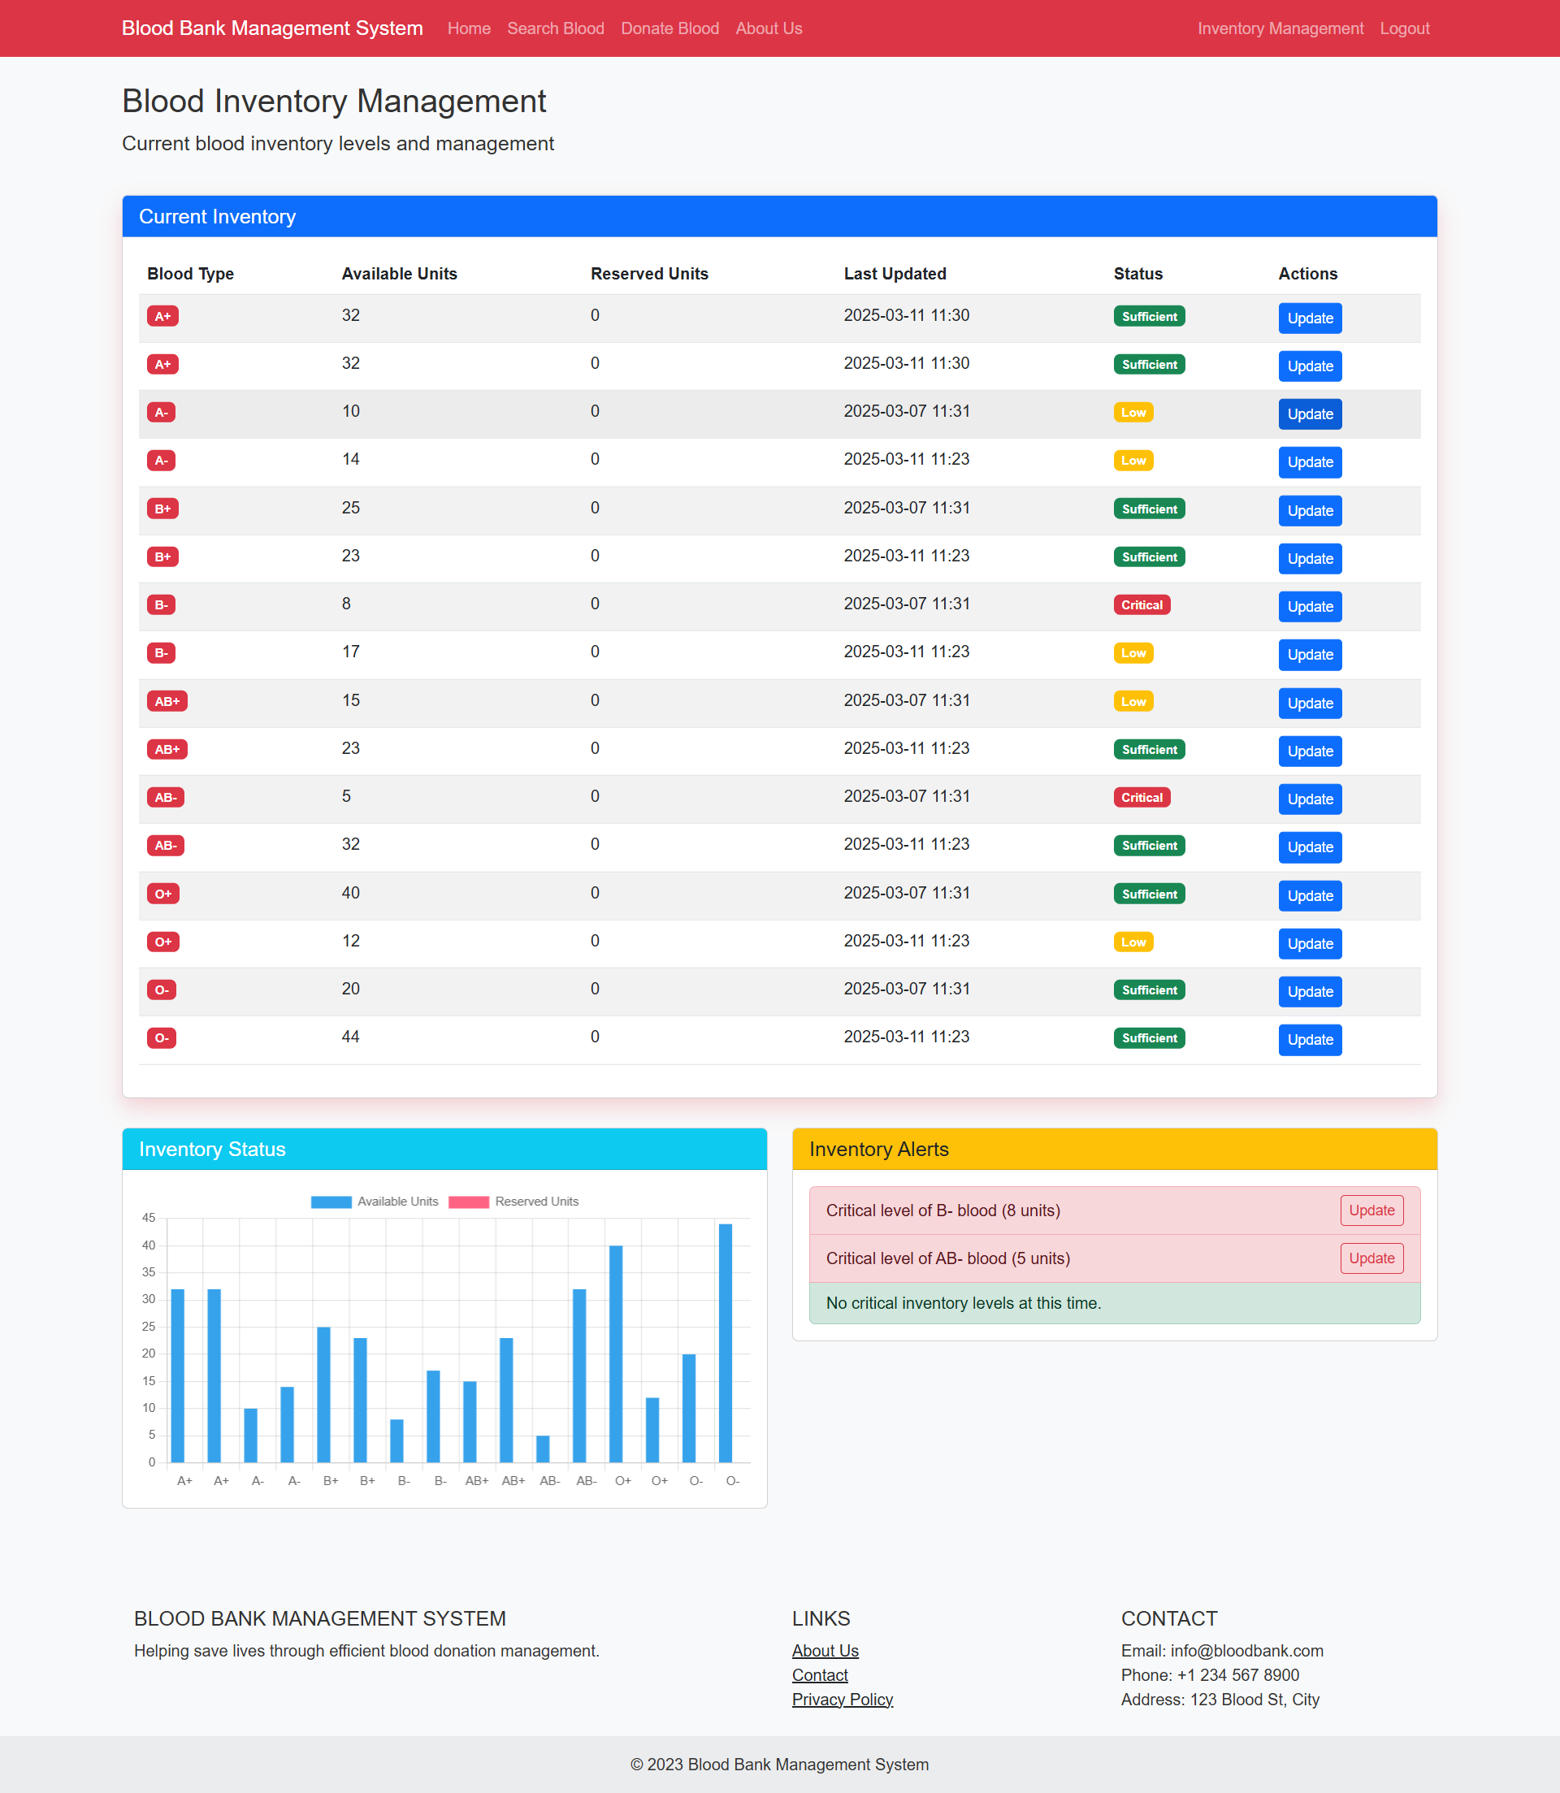

* Blood Inventory Update Page :

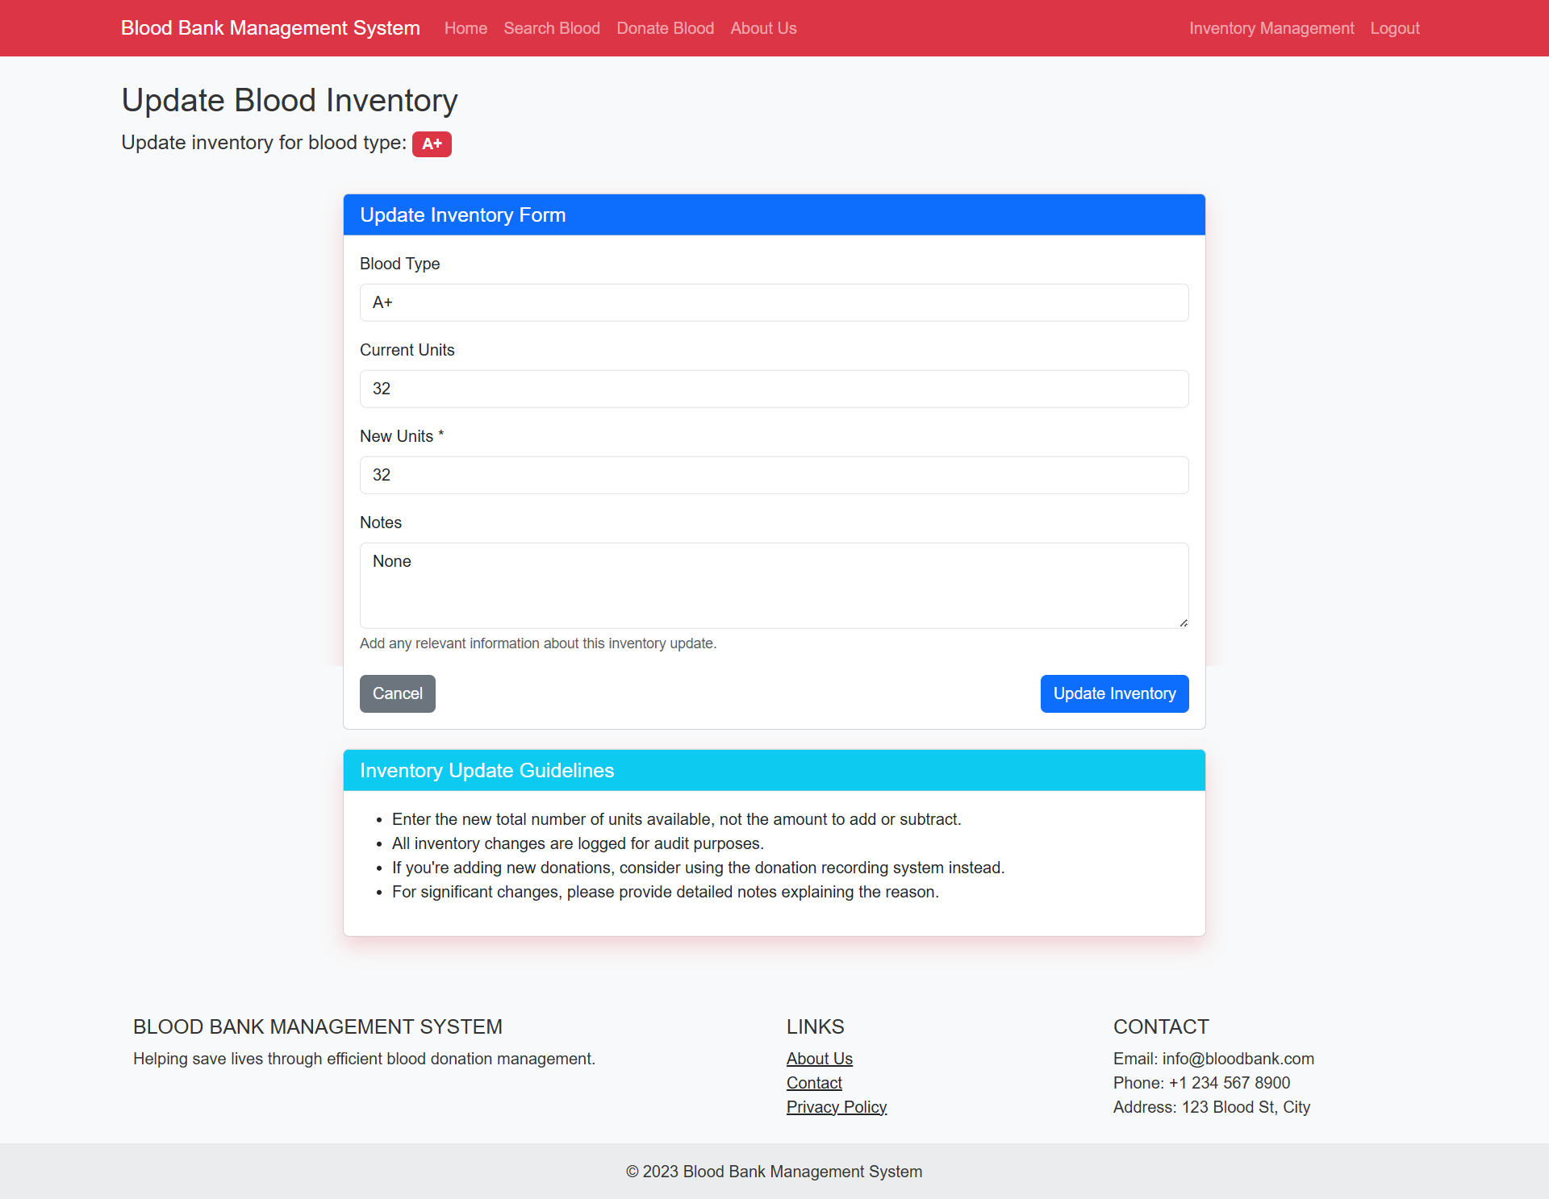

* Blood Request Page :   
  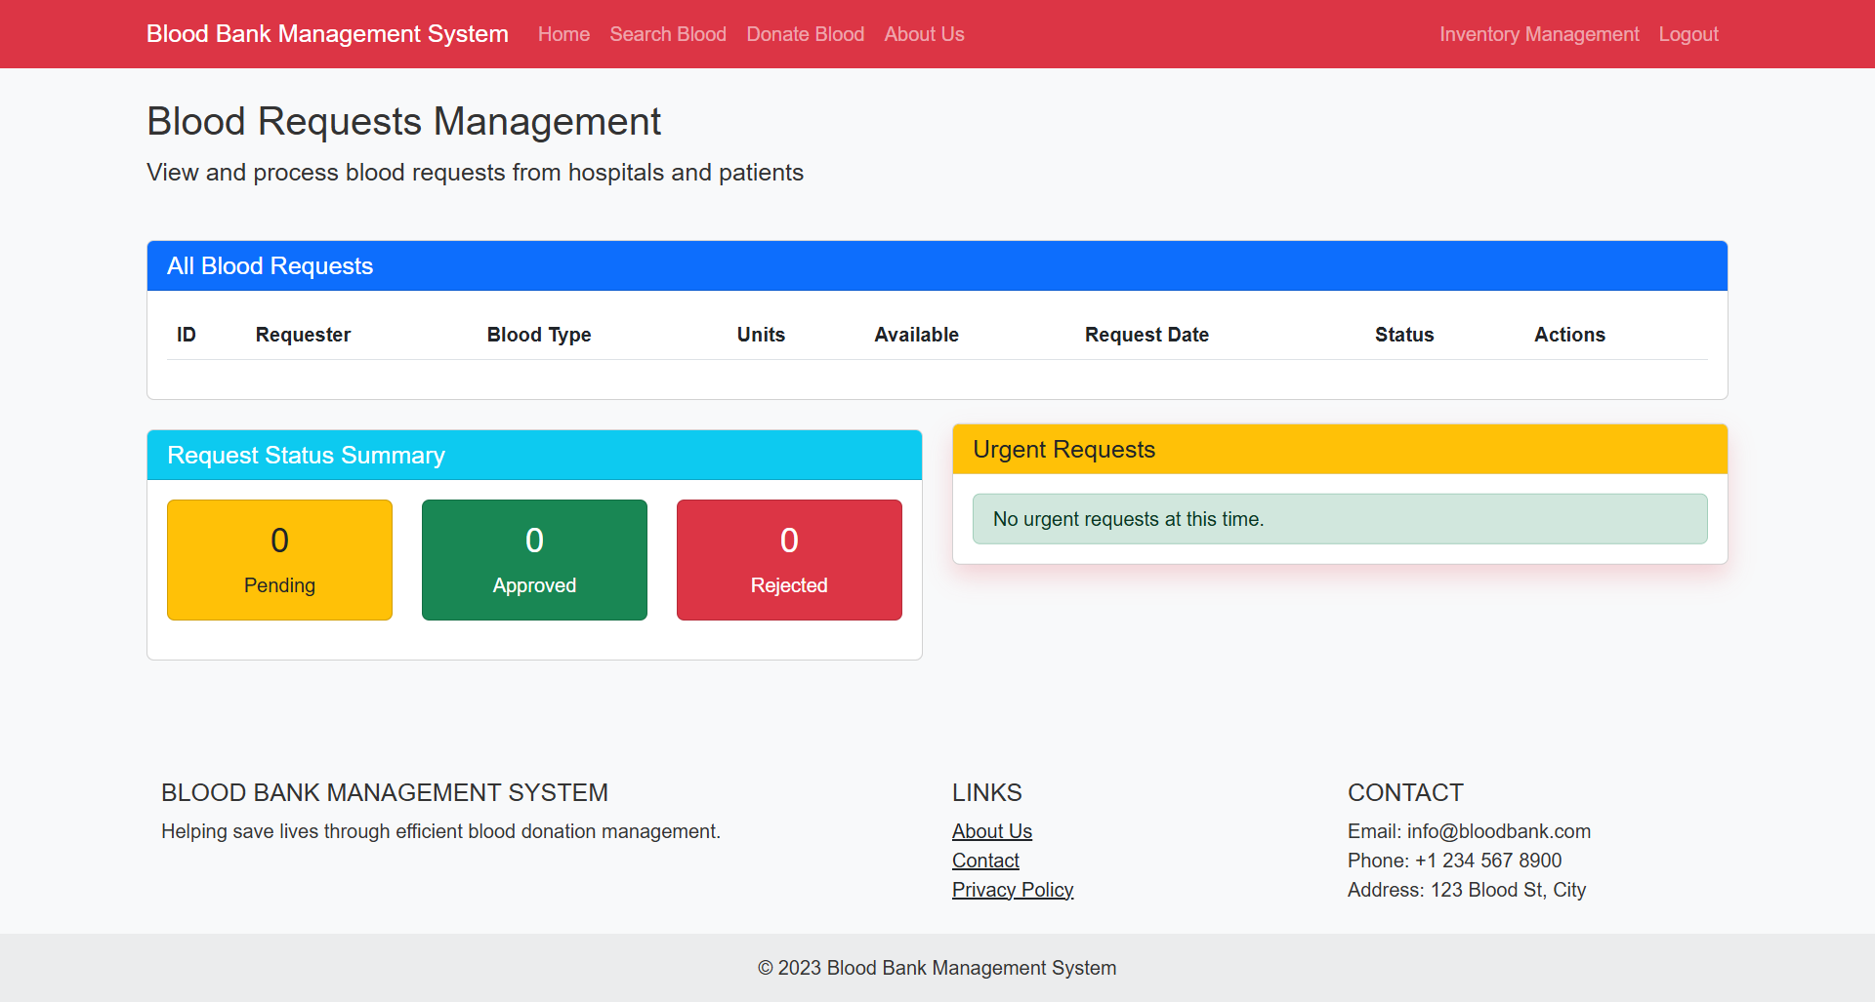
* Expiry Tracking Page

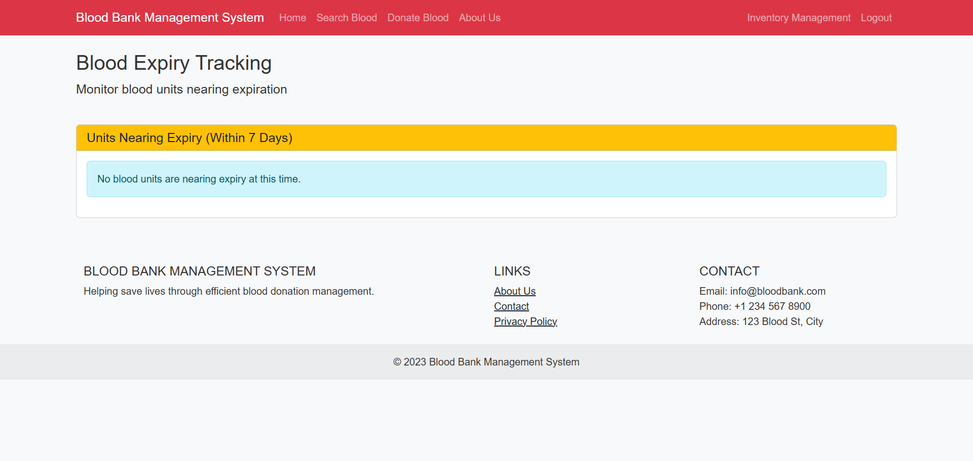

* Donor Collection Staff Registration Page

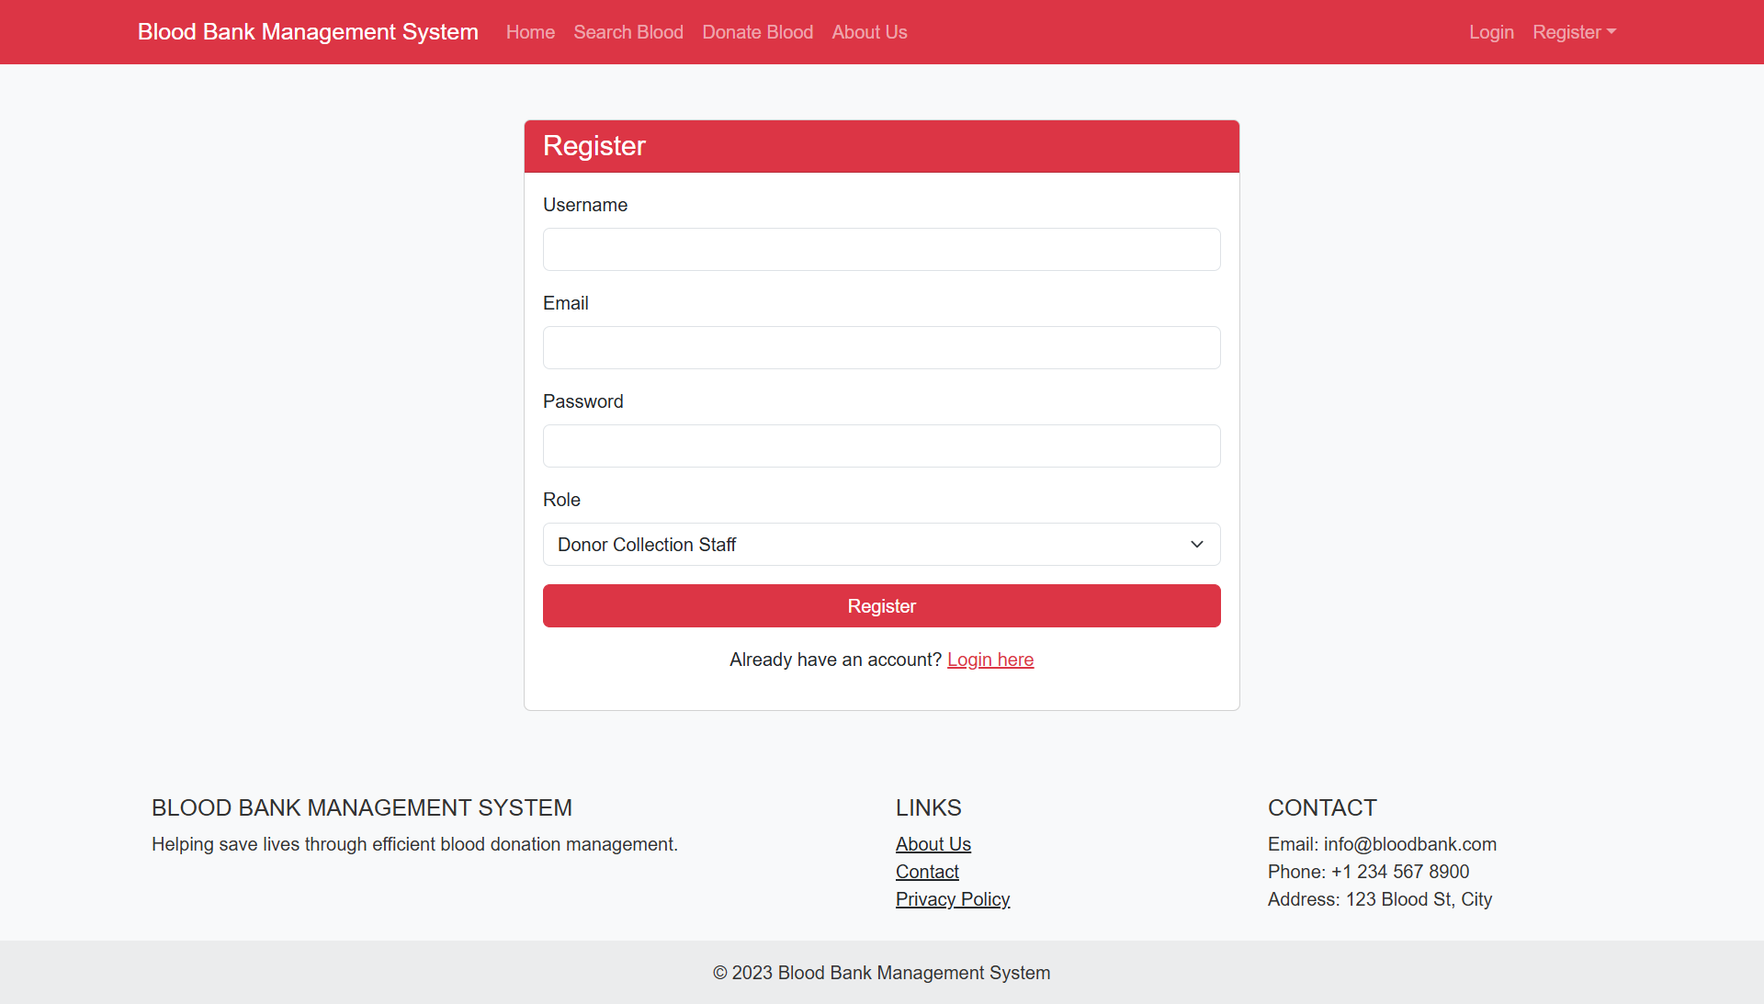

* Donor Staff Dashboard

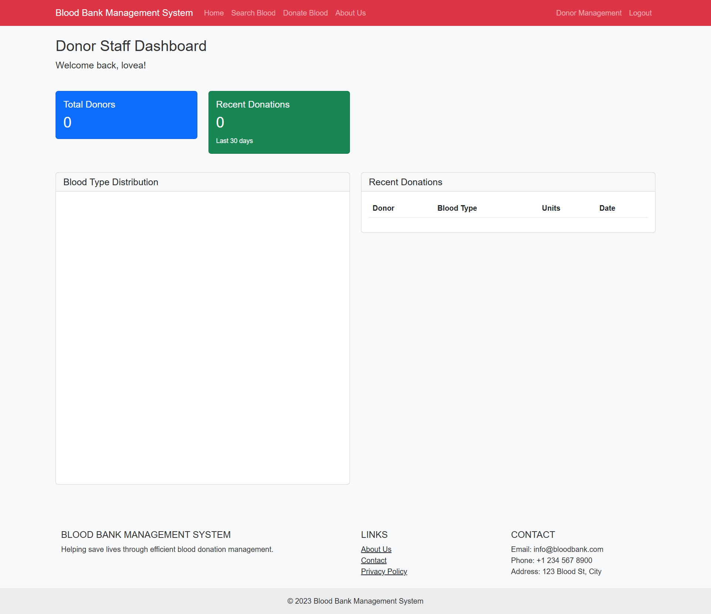

* New Donor Registration Page (and Update Page Once Registered)

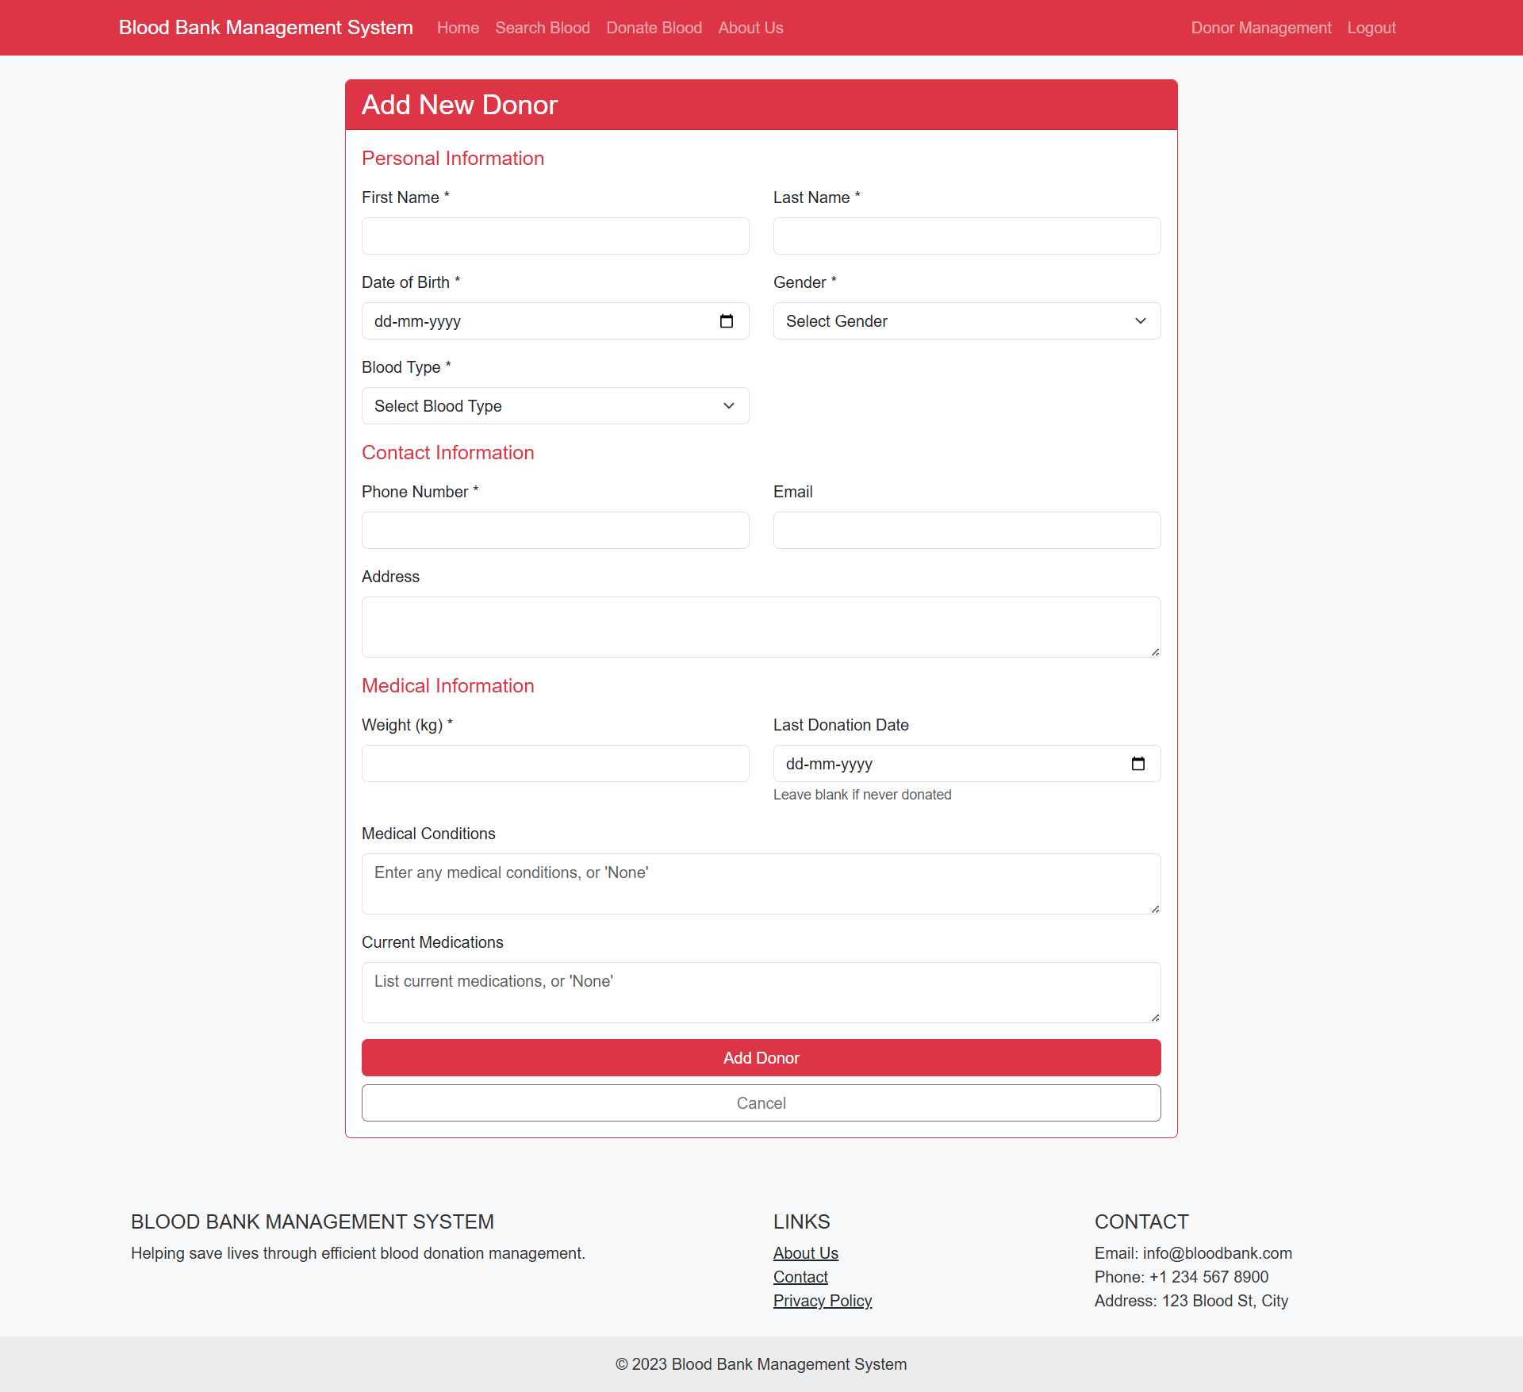

* Donor List Page

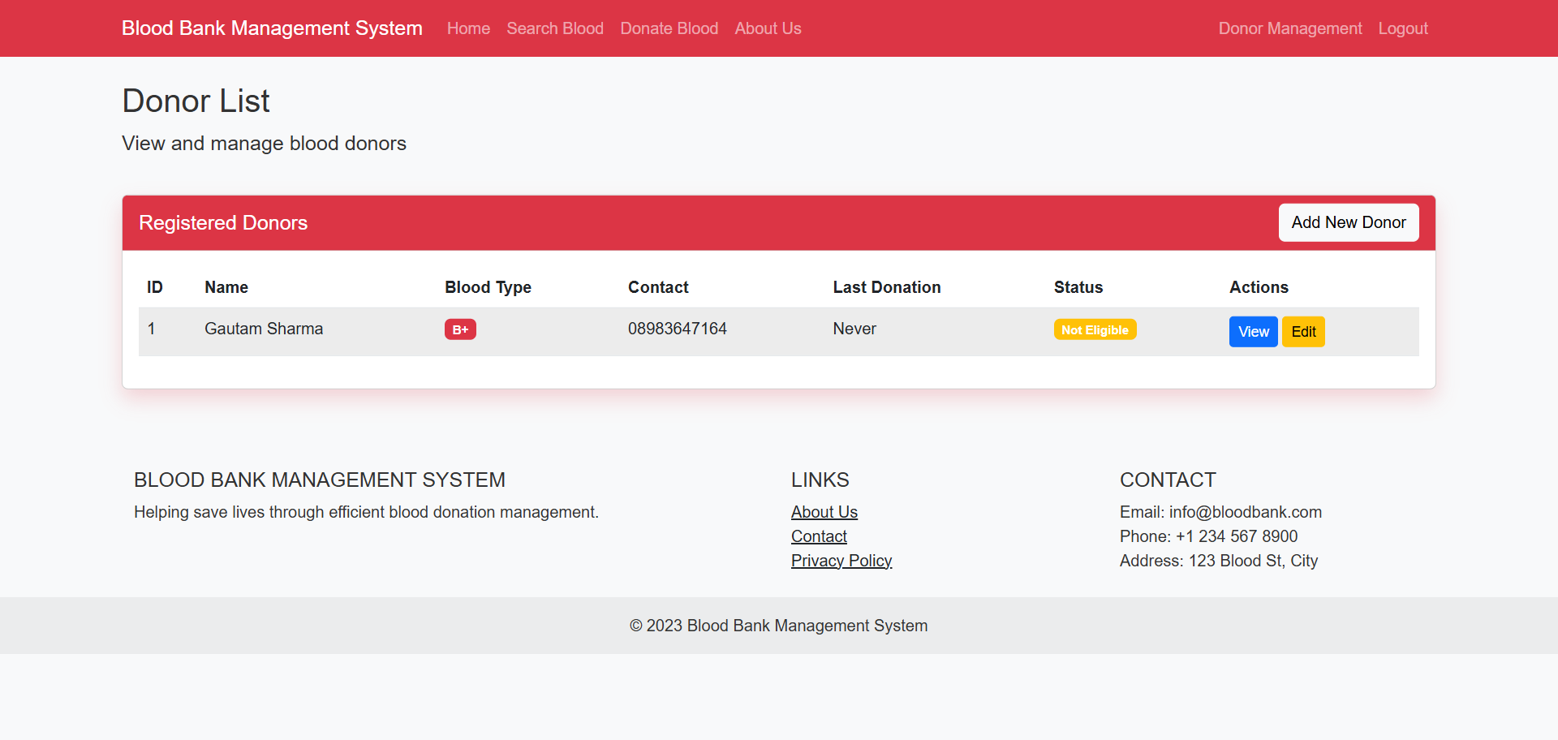

* Donor Details Page

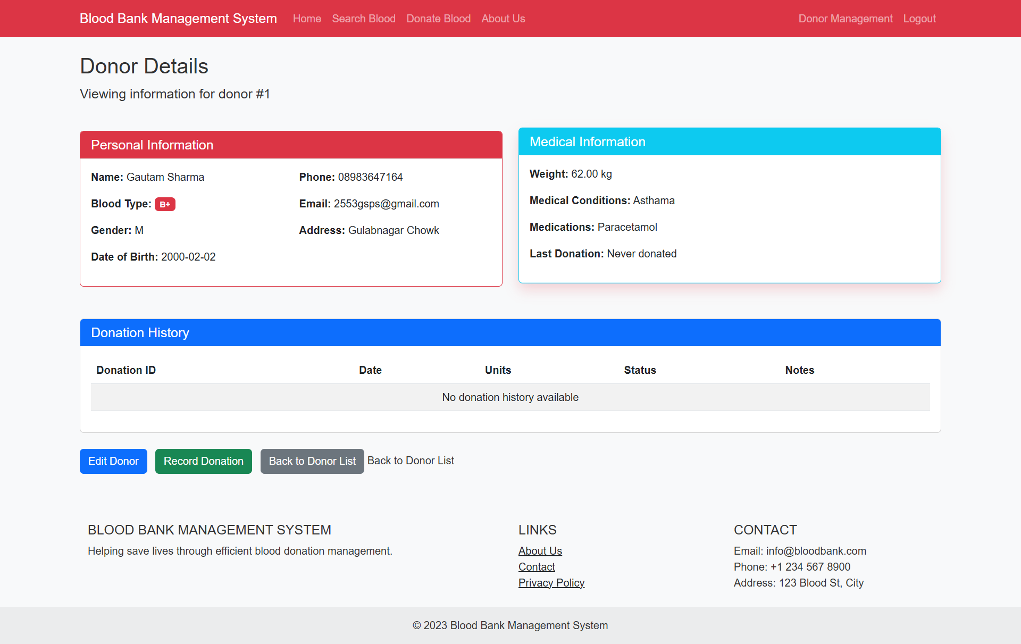

* Record New Donation

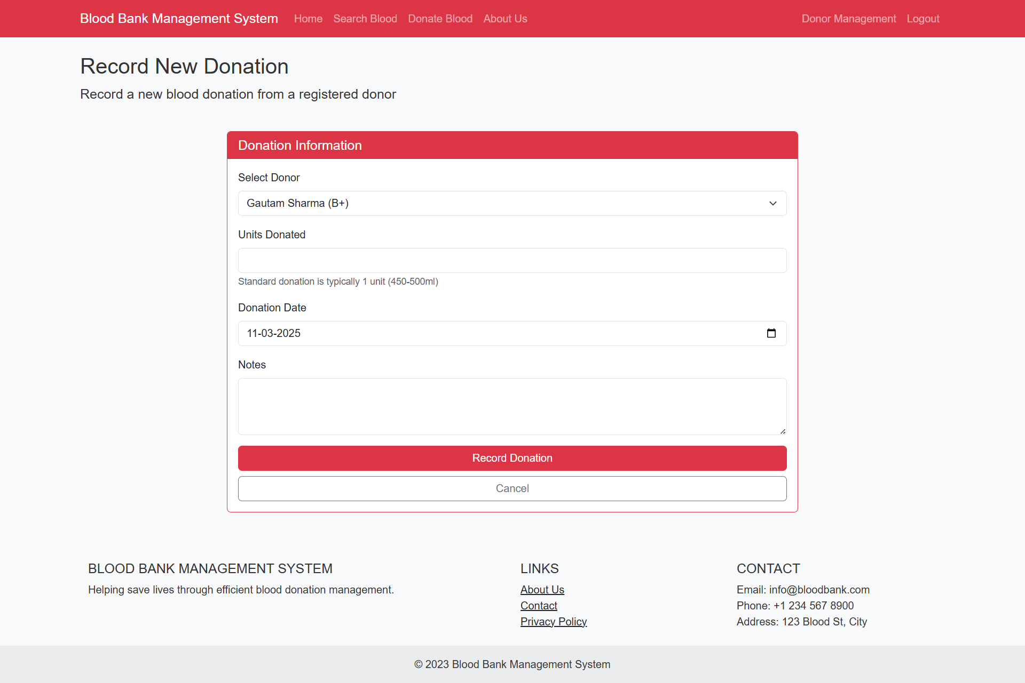

* All Blood Dontaions History

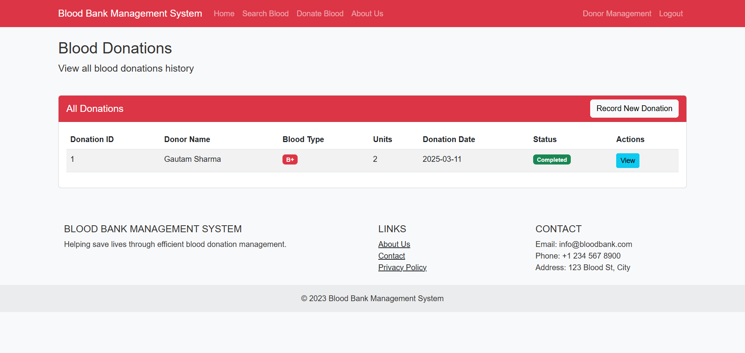

**7. Test Cases**

| **Test Case ID** | **Test Scenario** | **Test Steps** | **Expected Result** | **Status** |
| --- | --- | --- | --- | --- |
| TC_001 | User Registration | 1. Open the registration page  2. Enter valid details  3. Click "Submit" | User account should be created successfully | Pass/Fail |
| TC_002 | Invalid Registration Data | 1. Open the registration page  2. Enter invalid data (e.g., missing fields)  3. Click "Submit" | System should display appropriate error messages | Pass/Fail |
| TC_003 | User Login | 1. Open login page  2. Enter correct credentials  3. Click "Login" | User should be logged in successfully | Pass/Fail |
| TC_004 | Invalid Login | 1. Open login page  2. Enter incorrect credentials  3. Click "Login" | System should display "Invalid credentials" | Pass/Fail |
| TC_005 | Blood Donation Entry | 1. Admin logs in  2. Navigate to blood entry page  3. Add valid donation details  4. Click "Save" | Blood donation should be recorded successfully | Pass/Fail |
| TC_006 | Search Blood Availability | 1. User searches for a specific blood type  2. Click "Search" | System should display matching blood units | Pass/Fail |
| TC_007 | Blood Request | 1. User selects required blood group  2. Fills request form  3. Click "Submit" | Request should be processed successfully | Pass/Fail |
| TC_008 | Approving Blood Request | 1. Admin views pending requests  2. Approves a request  3. Confirms action | Blood should be marked as allocated | Pass/Fail |
| TC_009 | User Logout | 1. Click "Logout" button | User should be logged out and redirected to login page | Pass/Fail |
| TC_010 | Session Timeout | 1. Login as a user  2. Stay idle for the session timeout period | System should log out the user automatically | Pass/Fail |

**8.** **Conclusion and Recommendations**

**Conclusion:**

The Blood Bank Management System (BBMS) provides a centralized, automated solution to enhance the efficiency of blood donation, storage, and distribution. By integrating real-time inventory management, donor tracking, and automated notifications, the system reduces manual errors and improves response time during emergencies. The implementation of secure data handling and role-based access ensures privacy and reliability. With this system, hospitals, blood banks, and donors can coordinate effectively, ensuring that blood is available when needed, ultimately saving lives.

**Recommendations:**

- **Integration with Mobile Apps** – To improve accessibility, a mobile app should be developed to allow users to register, track donations, and receive alerts.

- **Public Awareness Campaigns** – Encourage more people to donate blood through social media promotions and collaboration with healthcare organizations.

- **AI-Based Predictions** – Implement machine learning to forecast blood demand based on historical trends and seasonal variations.

- **Cloud-Based System** – Adopt a cloud-based architecture to support large-scale implementation and multi-location blood bank coordination.

---

**9. Future Scope**

The Blood Bank Management System has the potential for expansion and innovation in the following areas:

✅ **AI-Powered Demand Forecasting :** Machine learning algorithms can be used to predict blood shortages based on location, season, and demand trends.

✅ **Blockchain for Donor & Inventory Security** **:** Implementing blockchain technology can enhance data security, ensure tamper-proof records, and create a transparent donor history.

✅ **Automated Blood Matching :** AI can help in smart donor-recipient matching based on blood type, antigen compatibility, and medical history.

✅ **Drone-Based Blood Delivery** **:** Integration with drone technology can speed up blood transportation in remote or disaster-hit areas.

✅ **Global Blood Bank Network :** A cloud-based interconnected global blood bank system can improve availability and reduce wastage worldwide.

---

**10. Bibliography and References**

📚 **Books & Research Papers** :

1. World Health Organization (WHO) – "Global Blood Safety and Availability."

2. "Medical Informatics: A Blood Bank Perspective" – John S. Smith, 2019.

3. "Artificial Intelligence in Healthcare" – Dr. Robert Williams, 2021.

🌐 **Online Sources** :

1. [World Health Organization – Blood Safety](https://www.who.int/health-topics/blood-products)

2. [National Blood Transfusion Council, India](http://nbtc.naco.gov.in/)

3. [American Red Cross – Blood Donation Guidelines](https://www.redcross.org/)

4. [Research on AI in Blood Bank Management](https://www.sciencedirect.com/)

🔬 **Technical References** :

- **Database Management** – MySQL

- **Software Development Frameworks** – Python (Flask)